T-Line Homework 1 (17 Points)
(jas, T-Line HW1.docx, 4/05/2025)

Include units and clearly label answers using 3 or 4 significant digits where appropriate. Show your work so that if necessary partial credit can be awarded.

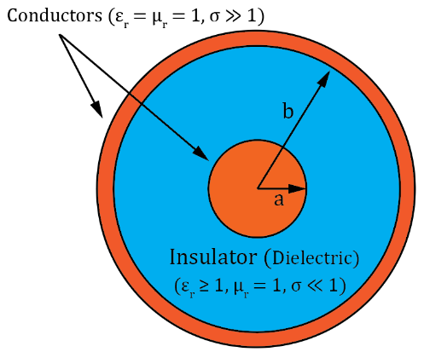
- A coaxial cable has the following parameters:
Dielectric: ε_{r} = 2.4. σ = 2 x 10⁻⁶ S/m.
Conductors: R_{s} = 2.6 x 10⁻⁴ Ω. σ = 5.8 x 10⁷ S/m. μ_{r} = 1.
a = 0.2 cm. b = 0.5 cm.

Determine the following values utilizing the relationships given in Table 2-1 for R’, G’, L’ and C’:

- R’. (2 points.)

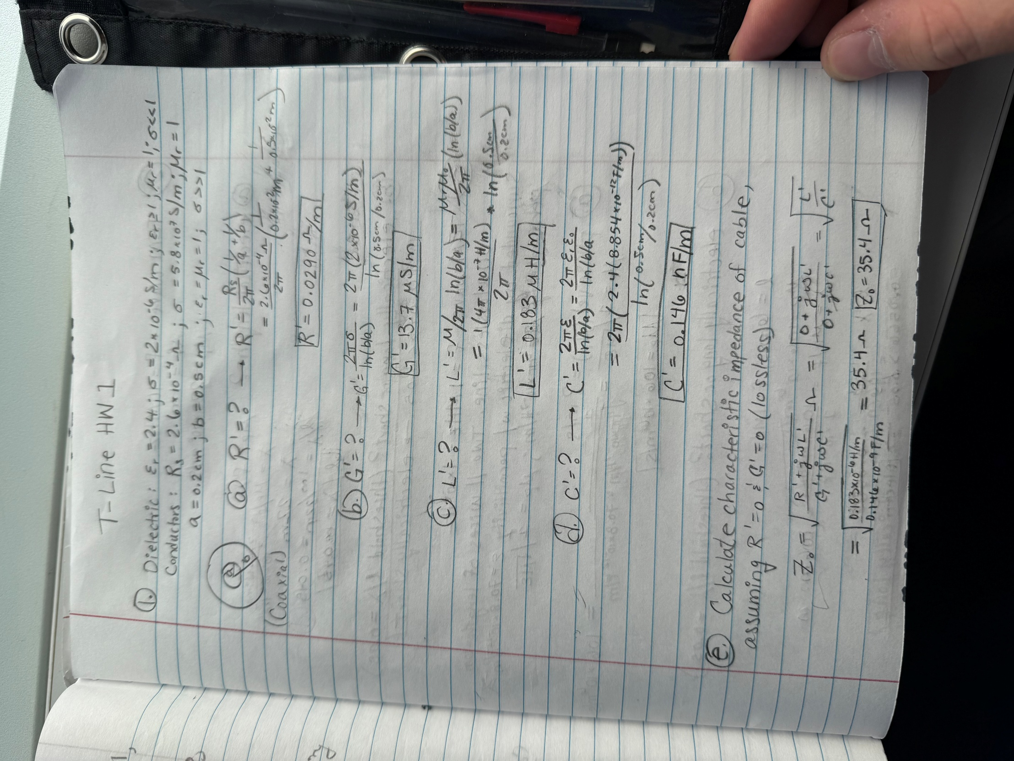

- G’. (2 points.)
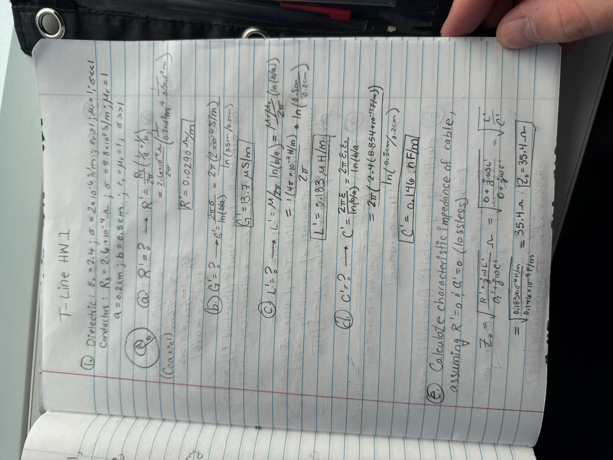

- L’. (2 points.)
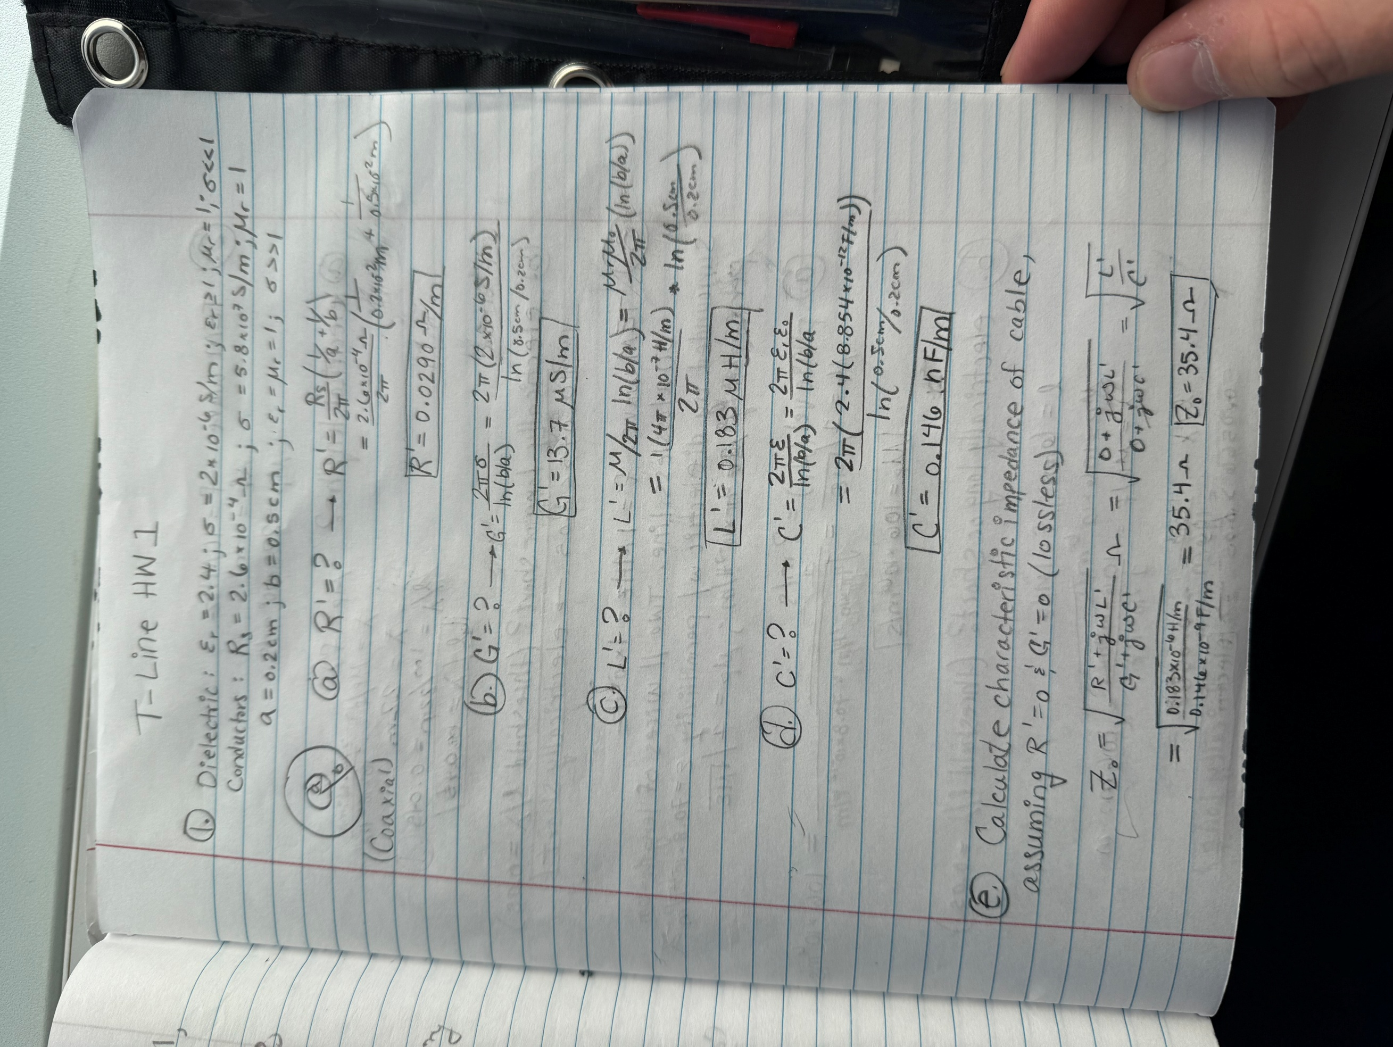

- C’. (2 points.)


- Calculate the characteristic impedance of the coaxial cable, assuming R’ and G’ equal zero, corresponding to a lossless transmission line. (Hint: Z₀ should be between 30 Ω and 40 Ω.) (2 points.)



- A TEM wave of frequency 10 MHz propagates on a 1-meter-long transmission line with a phase (propagation) velocity $u_{p}=220×{10}^{6}m/s.$

- Calculate the electrical length for this TEM wave. (Hint: The wavelength should be between 18 to 24 m.) (2 points.)
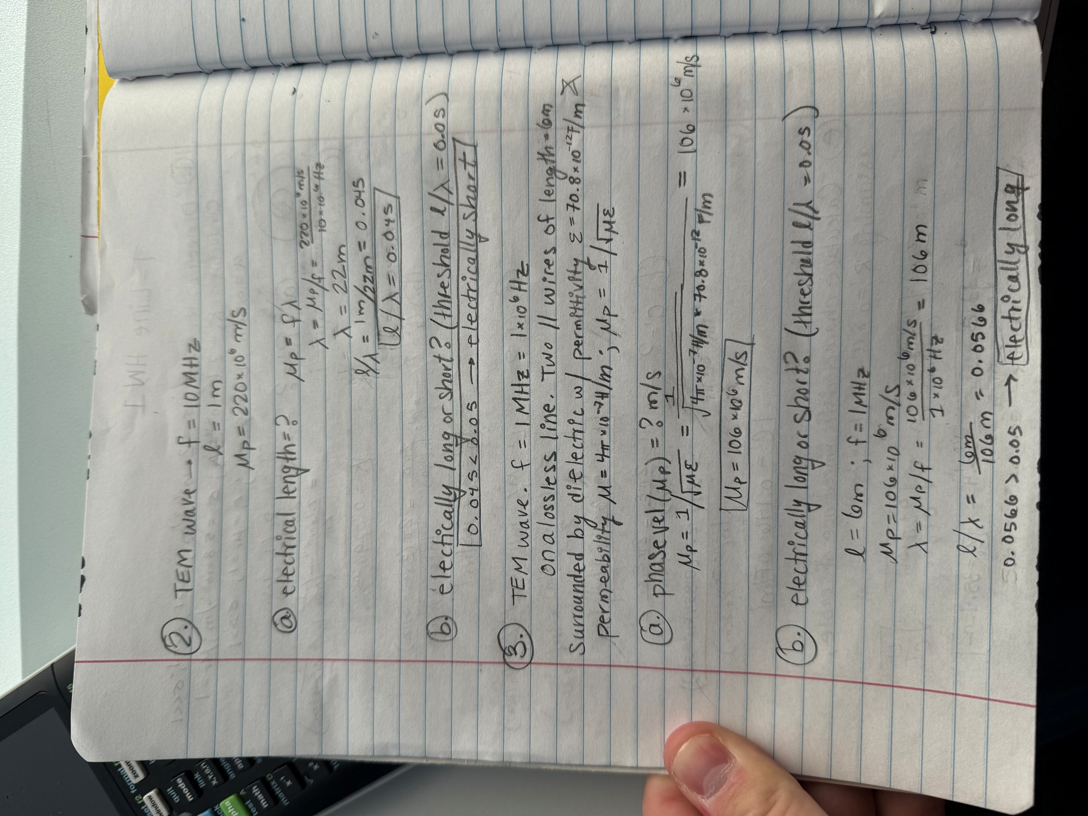

- Using a l/λ ratio threshold of 1/20 or 0.05 determine whether this transmission line is electrically short or electrically long. (1 point.)
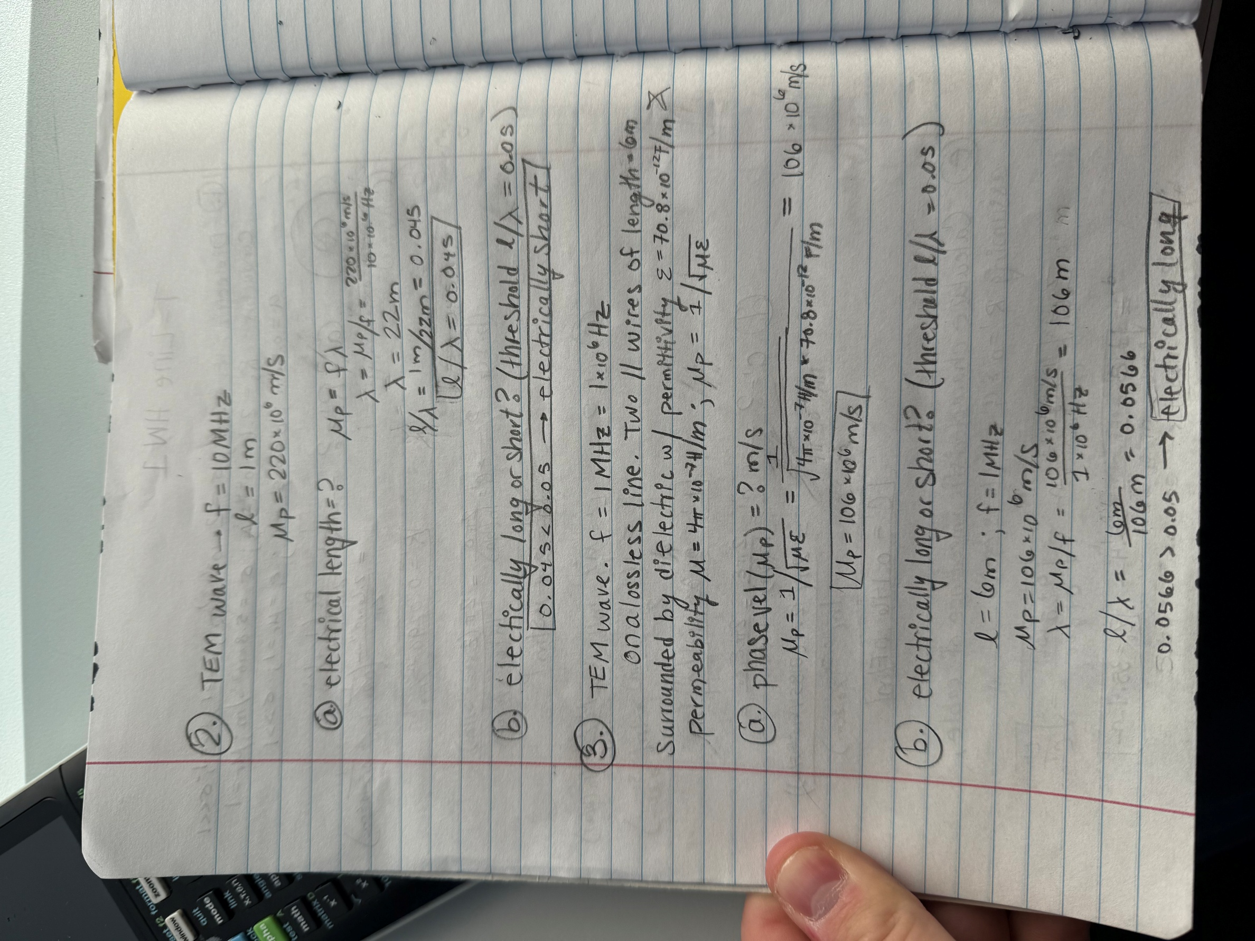

- A TEM wave of frequency 1 MHz propagates on a lossless transmission line consisting of two parallel wires of length 6 meters surrounded by a dielectric with a permittivity $ε=70.8×{10}^{-12}F/m$, and a permeability $μ=4π×{10}^{-7} H/m$, with the phase velocity given as $u_{p}=1/{\sqrt{με}}.$

- Determine the phase (propagation) velocity $u_{p} in units of m/s$ for the TEM wave. (Hint: Your answer should range between 100 x 10⁶ and 110 x 10⁶ m/s). (2 points.)

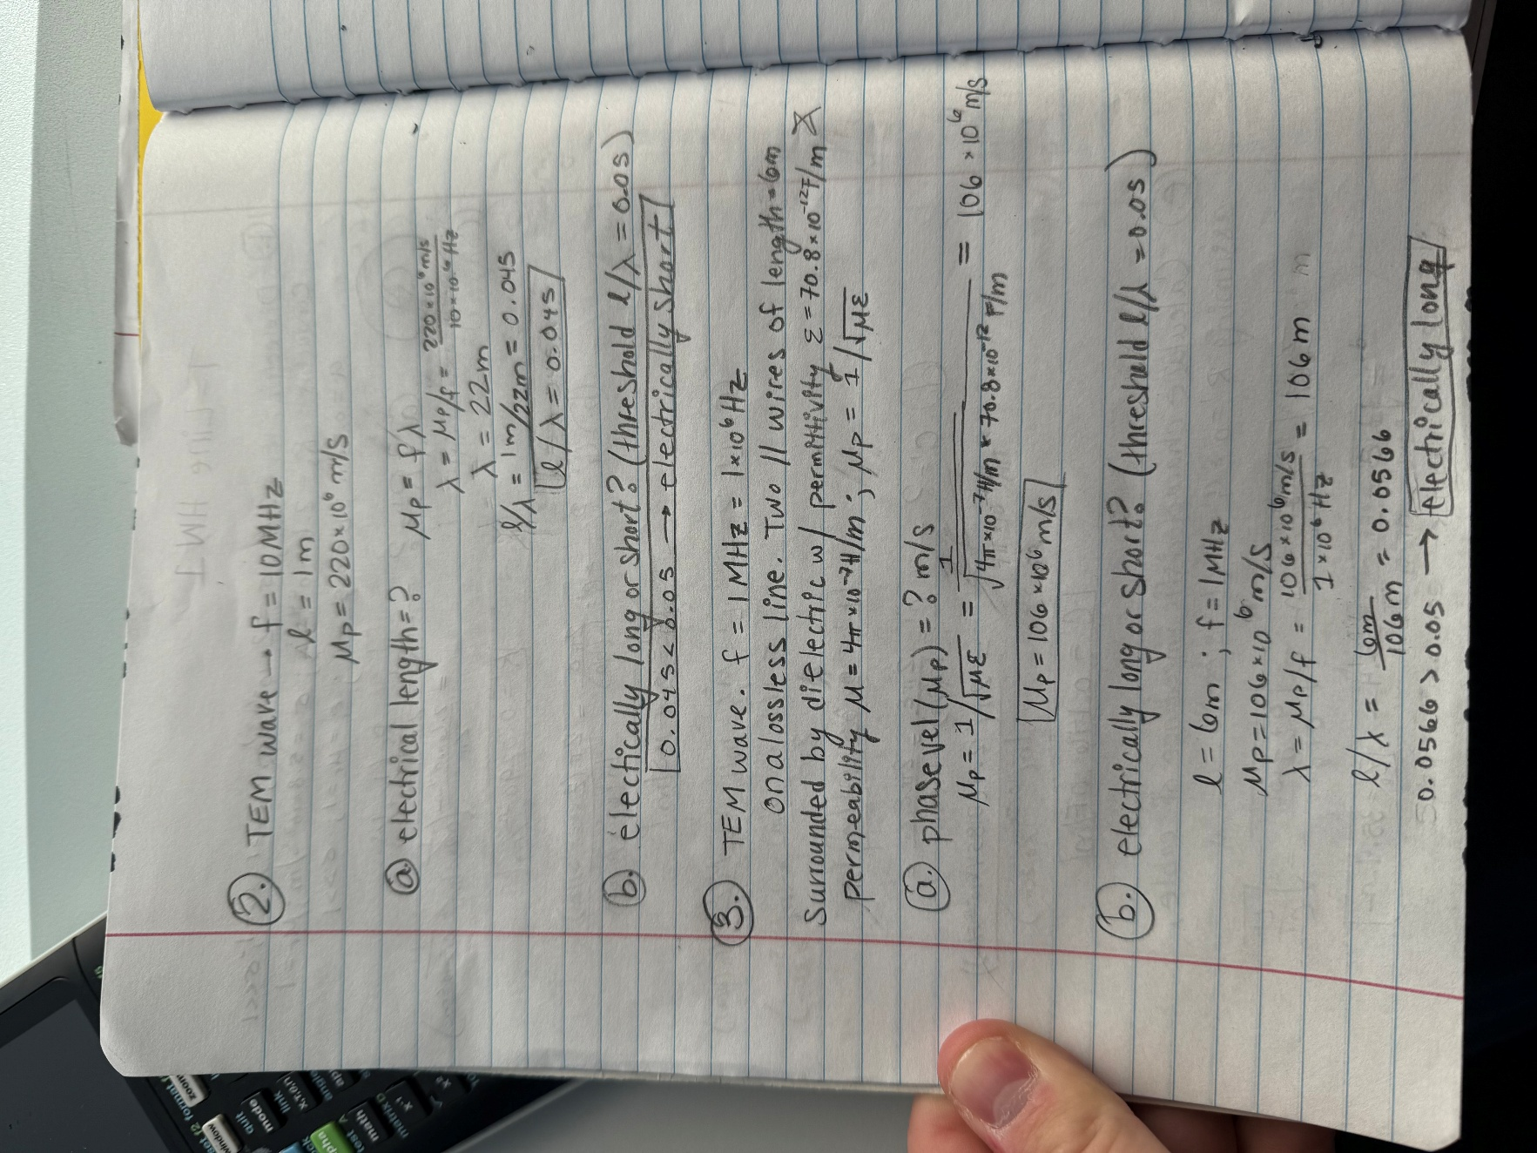

- Determine whether this transmission line is electrically short or electrically long using a l/λ ratio threshold of 1/20. (2 points.)
